**1. INTRODUCTION**

Reliable automatic recognition of persons has long been an attractive goal. As in all pattern recognition problems, the key issue is the relation between interclass and intra-class variability: objects can be reliably classified only if the variability among different instances of a given class is less than the variability between different classes. Iris patterns become interesting as an alternative approach to reliable visual recognition of persons when imaging can be done at distances of less than a meter, and especially when there is a need to search very large databases without incurring any false matches despite a huge number of possibilities. The iris has the great mathematical advantage that its pattern variability among different persons is enormous. In addition, as an internal (yet externally visible) organ of the eye, the iris is well protected from the environment and stable over time. As a planar object its image is relatively insensitive to angle of illumination, and changes in viewing angle cause only affine transformations; even the non-affine pattern distortion caused by pupillary dilation is readily reversible

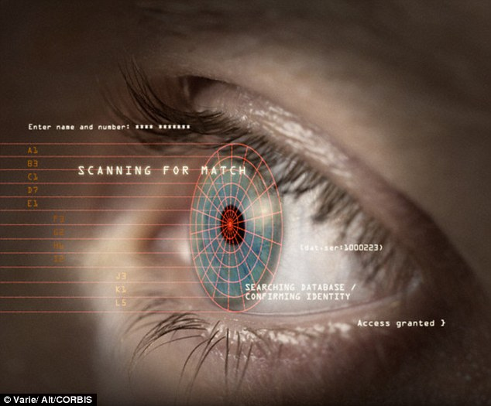

Finally, the ease of localizing eyes in faces, and the distinctive annular shape of the iris, facilitates reliable and precise isolation of this feature and the creation of a size-invariant representation.

Algorithms developed by Dr. John Daugman at Cambridge are today the basis for all iris recognition systems worldwide

**1.1 IRIS SCAN AND BIOMETRICS**

Biometrics, the use of a physiological or behavioral aspect of the human body for authentication or identification, is a rapidly growing industry. Biometric solutions are used successfully in fields as varied as e-commerce, network access, time and attendance, ATM’s, corrections, banking, and medical record access. Biometrics’ ease of use, accuracy, reliability, and flexibility are quickly establishing them as the premier authentication technology.

Iris recognition for an individual is carried out on the basis of the structure of the iris. This is because the structure of the iris offers the following characteristics:

* The structure of the iris is unique to an individual. During the course of examining large numbers of eyes, researchers have noted that the detailed pattern of an iris, even the left and right iris of a single person, seems to be highly distinctive.
* The structure of the iris is of an individual is stable with age. In research cases with repeated observations, the iris patterns seemed to vary little, at least past childhood.
* While the general structure of the iris is genetically determined, the particulars of its minutiae are critically dependent on circumstances. Therefore, they are highly unlikely to be replicated, in natural means.
* Another interesting aspect of the iris from a biometric point of view has to do with its moment-to-moment dynamics. Due to the complex interplay of the iris’ muscles, the diameter of the pupil is in a constant state of small oscillation. Potentially, this movement could be monitored to make sure that a live specimen is being evaluated.
* Further, since the iris reacts very quickly to changes in impinging illumination (e.g., on the order of hundreds of milliseconds for contraction), monitoring the reaction to a controlled illuminant could provide similar evidence.

**2. THEORY**

**2.1. IRIS RECOGNITION**

Iris recognition leverages the unique features of the human iris to provide an unmatched identification technology. So accurate are the algorithms used in iris recognition that the entire planet could be enrolled in an iris database with only a small chance of false acceptance or false rejection. The technology also addresses the FTE (Failure To Enroll) problems, which lessen the effectiveness of other biometrics. The tremendous accuracy of iris recognition allows it, in many ways, to stand apart from other biometric technology is based on research and patents held by Dr. John Daugman.

**2.2. THE IRIS**

Iris recognition is based on visible qualities of the iris. A primary visible characteristic is the trabecular meshwork (permanently formed by the 8th month of gestation), a tissue that gives the appearance of dividing the iris in a radial fashion. Other visible characteristics include rings, furrows freckles, and the corona. Expressed simply, iris recognition technology converts these visible characteristics into a 512 byte IRIS CODE, a template stored for future verification attempts. 512 bytes is a fairly compact size for a biometric template, but the quantity of information derived from the iris is massive. From the iris 11mm diameter, Dr. Daugman’s algorithms provide 3.4 bits of data per square mm this density of information is such that each iris can be said to have 266 unique “spots”, as opposed to 13-60 for traditional biometric technologies. This 266 measurements is cited in all iris recognition literature: after allowing for the algorithm’s correlative functions and for characteristics functions and for characteristics inherent to most human eyes, Dr. Daugman concludes that 173 “independent binary degrees-of-freedom” can be extracted from his algorithm - an exceptionally large number for a biometric

**3. THE IMPLEMENTATION / CONSTRUCTION**

The first step is location of the iris by a dedicated camera no more than 3 feet from the eye. After the camera situates the eye, the algorithm narrows in from the right and left of the iris to locate its outer edge. This horizontal approach accounts for obstruction caused by the eyelids. It simultaneously locates the inner edge of the iris (at the pupil), excluding the lower 90 degree because of inherent moisture and lighting issues. The monochrome camera uses both visible and infrared light, the latter of which is located in the 700-900 nm range.

Upon location of the iris, as seen above, an algorithm uses 2-D Gabor wavelets to filter and map segments of the iris into hundreds of vectors (known here as phasors). The wavelets of various sizes assign values drawn from the orientation and spatial frequency of select areas, bluntly referred to as the “what” of the sub-image, along with the position of these areas, bluntly referred to as the “where”. The “what” and “where” are used to form the Iris Code.

Not the entire iris is used: a portion of the top, as well as 45 degree of the bottom, is unused to account for eyelids and camera-light reflections.

For future identification, the database will not be comparing images of irises, but rather hexadecimal representations of data returned by wavelet filtering and mapping.

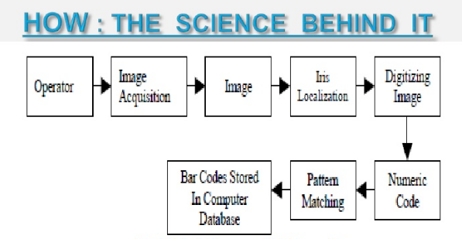

Fig: Block diagram of IRIS RECOGNITION

**4. WORKING**

**4.1 FINDING AN IRIS IN AN IMAGE**

To capture the rich details of iris patterns, an imaging system should resolve a minimum of 70 pixels in iris radius. In the field trials to date, a resolved iris radius of 100 to 140 pixels has been more typical. Monochrome CCD cameras (480 x 640) have been used because NIR illumination in the 700nm - 900nm band was required for imaging to be invisible to humans. Some imaging platforms deployed a wide-angle camera for coarse localization of eyes in faces, to steer the optics of a narrow-angle pan/tilt camera that acquired higher resolution images of eyes. There exist many alternative methods for finding and tracking facial features such as the eyes, and this well researched topic will not be discussed further here. In these trials, most imaging was done without active pan/tilt camera optics, but instead exploited visual feedback via a mirror or video image to enable cooperating Subjects to position their own eyes within the field of view of a single narrow-angle camera.

Focus assessment was performed in real-time (faster than video frame rate) by measuring the total high-frequency power in the 2D Fourier spectrum of each frame, and seeking to maximize this quantity either by moving an active lens or by providing audio feedback to Subjects to adjust their range appropriately. Images passing a minimum focus criterion were then analyzed to find the iris, with precise localization of its boundaries using a coarse - to - fine strategy terminating in single-pixel precision estimates of the center coordinates and radius of both the iris and the pupil.

Although the results of the iris search greatly constrain the pupil search, concentricity of these boundaries cannot be assumed. Very often the pupil center is nasal, and inferior, to the iris center. Its radius can range from 0.1 to 0.8 of the iris radius. Thus, all three parameters defining the pupillary circle must be estimated separately from those of the iris.

A very effective integrodifferential operator for determining these parameters is:

**Max (r,x0,y0) | G (r) * ∂/∂r ∫ (r,x0,y0) I(x; y) ds/2 πr | (1)**

Where I(x; y) is an image such as Fig 1 containing an eye. The operator searches over the image domain (x; y) for the maximum in the blurred partial derivative with respect to increasing radius r, of the normalized contour integral of I(x; y) along a circular arc ds of radius r and center coordinates (x0; y0). The symbol * denotes convolution and G(r) is a smoothing function such as a Gaussian of scale σ. The complete operator behaves in effect as a circular edge detector, blurred at a scale set by σ, which searches iteratively for a maximum contour integral derivative with increasing radius at successively finer scales of analysis through the three parameter space of center coordinates and radius (x0, y0, r) defining a path of contour integration.

The operator in (1) serves to find both the pupillary boundary and the outer

(limbus) boundary of the iris, although the initial search for the limbus also incorporates evidence of an interior pupil to improve its robustness since the limbic boundary itself usually has extremely soft contrast when long wavelength NIR illumination is used. Once the coarse-to-fine iterative searches for both these boundaries have reached single pixel precision, then a similar approach to detecting curvilinear edges is used to localize both the upper and lower eyelid boundaries. The path of contour integration in (1) is changed from circular to accurate, with spline parameters fitted by standard statistical estimation methods to describe optimally the available evidence for each eyelid boundary.

The result of all these localization operations is the isolation of iris tissue from other image regions, as illustrated in Fig 1 by the graphical overlay

.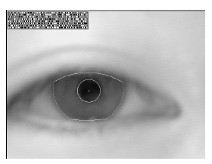

Fig : Illustration of poorly focused Eye

Only phase information is used for recognizing irises because amplitude information is not very discriminating, and it depends upon extraneous factors such as imaging contrast, illumination, and camera gain. The phase bit settings which code the sequence of projection quadrants as shown in Fig. capture the information of wavelet zero-crossings, as is clear from the sign operator in (2). The extraction of phase has the further advantage that phase angles are assigned regardless of how low the image contrast may be, as illustrated by the extremely out-of-focus image in Fig 3. Its phase bit stream has statistical properties such as run lengths similar to those of the code for the properly focused eye image in Fig 1. (Fig 3 also illustrates the robustness of the iris- and pupil - finding operators, and the eyelid detection operators, despite poor focus.)

The benefit which arises from the fact that phase bits are set also for a poorly focused mage as shown here, even if based only on random CCD noise, is that different poorly focused irises never become confused with each other when their phase codes are compared. By contrast, images of different faces look increasingly alike when poorly resolved, and may be confused with each other by appearance-based face recognition algorithms.

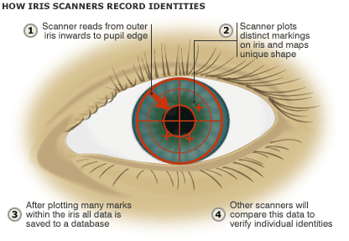

Fig: How iris scanners record identities

**5. ADVANTAGES**

The iris of the eye has been described as the ideal part of the human body for biometric identification for several reasons:

* It is an internal organ that is well protected against damage and wear by a highly transparent and sensitive membrane (the [cornea](http://en.wikipedia.org/wiki/Cornea)). This distinguishes it from fingerprints, which can be difficult to recognize after years of certain types of manual labor.
* The iris is mostly flat, and its geometric configuration is only controlled by two complementary muscles (the sphincter pupillae and dilator pupillae) that control the diameter of the pupil. This makes the iris shape far more predictable than, for instance, that of the face.
* The iris has a fine texture that—like fingerprints—is determined randomly during embryonic [gestation](http://en.wikipedia.org/wiki/Gestation). Like the fingerprint, it is very hard (if not impossible) to prove that the iris is unique. However, there are so many factors that go into the formation of these textures (the iris and fingerprint) that the chance of false matches for either is extremely low. Even genetically identical individuals have completely independent iris textures.
* An iris scan is similar to taking a photograph and can be performed from about 10 cm to a few meters away. There is no need for the person being identified to touch any equipment that has recently been touched by a stranger, thereby eliminating an objection that has been raised in some cultures against fingerprint scanners, where a finger has to touch a surface, or retinal scanning, where the eye must be brought very close to an eyepiece (like looking into a microscope).
* The commercially deployed iris-recognition algorithm, [John Daugman](http://en.wikipedia.org/wiki/John_Daugman)'s IrisCode, has an unprecedented [false match](http://en.wikipedia.org/wiki/Type_I_and_type_II_errors#Type_I_error) rate (better than 10−11 if a Hamming distance threshold of 0.26 is used, meaning that up to 26% of the bits in two IrisCodes are allowed to disagree due to imaging noise, reflections, etc., while still declaring them to be a match).[[5]](http://en.wikipedia.org/wiki/Iris_recognition#cite_note-5)

**6. SHORTCOMINGS**

* Many commercial iris scanners can be easily fooled by a high quality image of an iris or face in place of the real thing.
* The accuracy of scanners can be affected by changes in lighting.
* Iris scanners are significantly more expensive than some other forms of biometrics, password or proxy card security systems.
* Iris scanning is a relatively new technology and is incompatible with the very substantial investment that the law enforcement and immigration authorities of some countries have already made into fingerprint recognition.
* Iris recognition is very difficult to perform at a distance larger than a few meters and if the person to be identified is not cooperating by holding the head still and looking into the camera. However, several academic institutions and biometric vendors are developing products that claim to be able to identify subjects at distances of up to 10 meters ("standoff iris" or "iris at a distance" as well as "iris on the move" for persons walking at speeds up to 1 meter/sec).
* As with other photographic biometric technologies, iris recognition is susceptible to poor image quality, with associated failure to enroll rates.
* As with other identification infrastructure (national residents databases, ID cards, etc.), civil rights activists have voiced concerns that iris-recognition technology might help governments to track individuals beyond their will.
* Researchers have tricked iris scanners using images generated from digital codes of stored irises. Criminals could exploit this flaw to steal the identities of others.
* Alcohol consumption causes recognition degradation as the [pupil](http://en.wikipedia.org/wiki/Pupil) dilates/constricts causing deformation in the [iris](http://en.wikipedia.org/wiki/Iris_%28anatomy%29) pattern.

**7. IRIS RECOGNITION IN ACTION**

Iris-based identification and verification technology has gained acceptance in a no: of different areas. Where as the technology in its early days was fairly cumbersome and expensive, recent technological breakthroughs have reduced both the size and prize of iris recognition (also know informally as iris scan) devices. This, in turn, has allowed for much grater flexibility of implementation. Iris-based biometric technology has always been an exceptionally accurate one, and it may soon grow much more prominent.

**Applications:**

* Computer login: the iris as a living password
* National border controls: the iris as a living passport
* Telephone call charging without cash, cards, or PIN numbers
* Secure access to bank cash machine accounts
* Ticket less air travel
* driving licenses, and other personal certificate
* Forensics: birth certificates
* Tracing missing or wanted persons
* Anti-terrorism
* “Biometric-key cryptography” for encrypting/decrypting messages
* Automobile ignition and unlocking
* Credit card authentication
* Internet security; control of access to privileged information

**8. CONCLUSION**

For at least a century, it has been suggested that the iris can subserve biometrically based recognition of human individuals.

Recent efforts in machine vision have yielded automated systems that take strides toward realizing this potential. As currently instantiated, these systems are relatively compact and efficient and have shown promising performance in preliminary testing.

An important direction for future efforts is the design and execution of controlled, large-scale research studies. Only via reference to such studies can the true accuracy of iris recognition be determined for both the verification and identification tasks.

Another potential direction for future research would be to relax the constraints under which current iris-recognition systems operate. With this in mind, it would be particularly desirable to decrease the required level of operator participation even while increasing the physical distance from which evaluation takes place.

If such goals can be achieved, then iris recognition can provide the basis for truly noninvasive biometric assessment. Further, if these enhancements can be had while maintaining compact, efficient, and low-cost implementations, then iris recognition will be well positioned for widespread deployment.

**9. REFERENCES**

* The paper referenced is “Iris Recognition: An Emerging Biometric Technology”, which is authored by Richard P. Wildes. Richard P. Wildes is also a member IEEE. He is also the co-creator of the Wildes Iris Recognition technology.
* <https://www.cylab.cmu.edu/partners/success-stories/iris-recognition.html>
* <http://www.academia.edu>
* <https://biomedical-engineering-online.biomedcentral.com/articles/10.1186/1475-925X-3-2>